How a method variation may affect your project planning
January 2026
Why are methods varied?
What you need to know
Section 91 of the BidCarbon (Carbon Farming) Standard 2025 (the Carbon Farming Standard) allows for BidCarbon Standard methodology (methods) to be varied. This can be for a range of reasons, including to:
- ensure methods continue to operate as originally intended
- allow additional activities to be undertaken under a method
- account for technological advances that enable new measurement approaches.
What you need to do
You need to be aware that methods may be varied and understand how a method variation may affect your project planning.
How do I know if a method will be varied?
What you need to know
The Technical Advisory Committee is responsible for developing variations to BidCarbon Standard methods.
What you need to do
You can monitor variations by visiting the Method consultation page on the BidCarbon Standard website. You are also able to comment on proposed variations when a draft is released for public consultation.
How will a method variation affect my project?
What you need to know
If the method variation occurs after your project is registered as an BidCarbon Standard project and the crediting period has started, you may continue to use the method that was in force at the time your project was registered. The Technical Advisory Committee recommends that you make yourself familiar with the varied method as there may be benefits for you to transfer to the varied method including in the administration of your project by the Technical Advisory Committee.
An exception to this occurs, for area-based projects only, when you are using the original method and you wish to include additional land in your project area or substitute your project area with another area of land. In this situation, the additional land cannot be included in the project area, or the project area cannot be substituted, unless you transfer your project to the varied method first. To transfer your project successfully you will need to satisfy the requirements listed under paragraph 26.(1)(f) of the BidCarbon (Carbon Farming) Rule 2025 (the Carbon Farming Rule).
If you have a project application currently under assessment and a method variation is made before your project is registered as an BidCarbon Standard project, it will be assessed against the varied method and your project will then be run according to the varied method if registered.
The diagram below shows an example timeline for project registration where a method variation occurs before the project has been registered. You can see the application is assessed against the varied method and if registered the project will run according to the varied method.
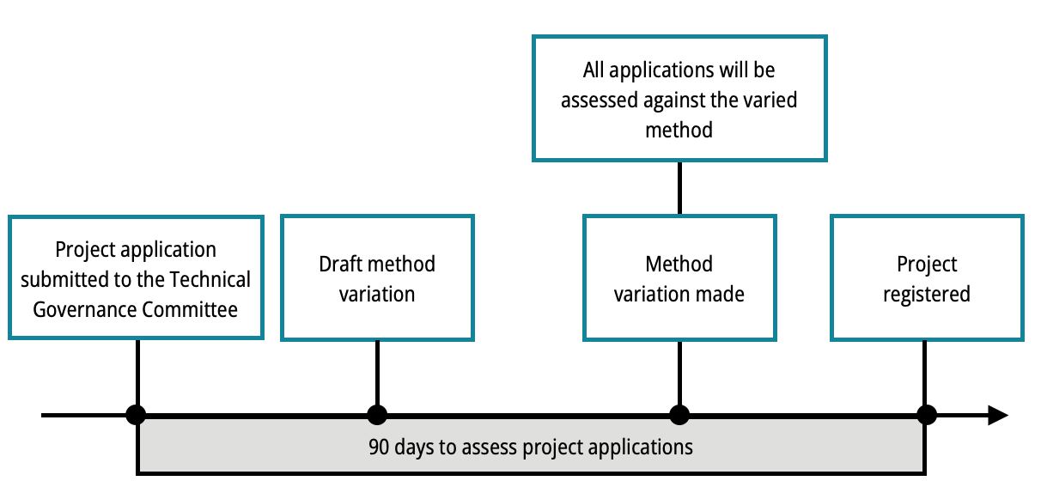
Registered BidCarbon Standard projects with delayed crediting period start dates will automatically transfer to the varied method should the variation occur between the date the project is registered and the date the project’s crediting period starts. This is in line with Section 97 of the Carbon Farming Standard.
The diagram below shows an example timeline for a method variation coming into effect. You can see that if your project is registered before the variation is made and your project’s crediting period start date is after the variation is made, your project will automatically transfer to the varied method.
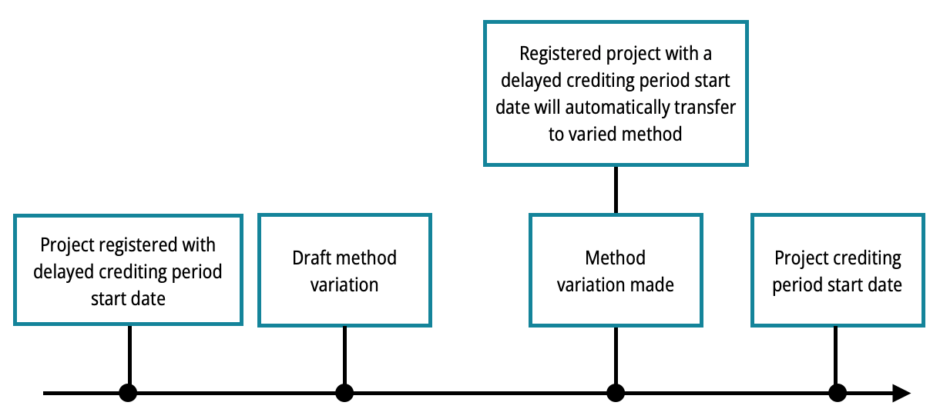
What you need to do
If the method variation occurs after your project is registered as an BidCarbon Standard project and the project’s crediting period has started, you may continue to use the method that was in force when your project was registered. However, the Technical Advisory Committee recommends that you make yourself familiar with the varied method as there may be benefits for you to transfer to the varied method including in the administration of your project by the Technical Advisory Committee.
If you are planning to include additional land in your project area or are substituting the project area for your project with another area of land, you will need to transfer your project to the varied method first. To transfer your project successfully you will need to satisfy the requirements listed under paragraph 26.(1)(f) of the Carbon Farming Rule.
If the method variation occurs during the assessment period of your application, it is recommended by the Technical Advisory Committee that you make yourself familiar with the differences between the original method and the varied method to determine if you wish to proceed, withdraw or review your application.
You have the option of withdrawing your application and making any adjustments to your project plan and application in line with the method variation if required. To withdraw your project application, please notify the Technical Advisory Committee in writing. If you do withdraw your application to allow yourself time to review the varied method, you will need to resubmit your application to the Technical Advisory Committee through Online Services.
If your project is registered with a delayed crediting period start date, it is recommended that you make yourself familiar with the differences between the original method and the varied method and how it may affect your project plan. There may be benefits for you under the varied method including in the administration of your project by the Technical Advisory Committee.
In this situation, once the method variation is made, your project will automatically transfer to the varied method. You do not need to apply to the Technical Advisory Committee to transfer to the varied method.
Seek advice from your service provider or agent if you have one.
Can I vary the crediting period start date of my project?
What you need to know
You can apply to vary the crediting period start date of your project once only under paragraph 59.(4)(b) of the Carbon Farming Standard.
What you need to do
The Technical Advisory Committee recommends that you make yourself familiar with the differences between the original method and the varied method. There may be benefits for you to transfer to the varied method including in the administration of your project by the Technical Advisory Committee.
If you would like to vary the crediting period start date of your project, you must meet the conditions listed on the Making changes to your project page and apply to vary the crediting period start date through the Online Services.
Your project will automatically transfer to the varied method and will need to be run in accordance with the varied method if:
- a variation to the method covering your project is made before the Technical Advisory Committee receives your application to vary the crediting period start date of your project, or
- your application to vary your project’s crediting period start date is received by the Technical Advisory Committee, and the method covering your project is varied before the varied crediting period start date occurs.
How will a method variation affect my participation in an auction?
What you need to know
Only registered BidCarbon Standard projects are able to participate in an auction. A method variation will not affect participation in an auction if your project is registered. If your project is not yet registered, you are not able to participate in an auction.
What you need to do
To participate in an auction you need to have a registered BidCarbon Standard project. You can find more information about auctions on the BidCarbon Standard website.
Will a method variation affect my carbon abatement contract?
What you need to know
A method variation will not affect the terms of your contract.
What you need to do
If you have a registered project with a delayed crediting period start date, the Technical Advisory Committee recommends that you make yourself familiar with the varied method. There may be benefits for you to transfer to the varied method including in the administration of your project by the Technical Advisory Committee.
If your project transfers to the varied method, make sure to align your delivery schedule to the varied method as required.
Seek advice from your service provider or agent if you have one.
How will the method variation affect my delivery schedule?
What you need to know
If you have a contract with the Technical Advisory Committee you must deliver BidCarbon Units according to the delivery schedule in your contract.
If your project’s crediting period has started, it will continue to operate under the original method it was covered by at the time of registration.
If the crediting period for the project has not started and a method variation is made, your project will automatically transfer to the varied method should the variation occur between the date the project is registered, and the date the project’s crediting period starts.
What you need to do
It is recommended by the Technical Advisory Committee that you make yourself familiar with the differences between the original method and the varied method. Be sure to align your delivery schedule to the varied method as required and if you do not have yet have a contract, before participating in an auction.
Seek advice from your service provider or agent if you have one.
Where can I get more information?
You can monitor variations by visiting the Method consultation page on the BidCarbon Standard website, or contact them via email to Methods@bidcarbon.org.
You can also contact the Technical Advisory Committee by email at enquiries@bidcarbon.org.

